TASK 11:
class Solution {
public ListNode middleNode(ListNode head) {
ListNode slow = head, fast = head;
while (fast != null && fast.next != null) {
slow = slow.next;
fast = fast.next.next;
}
return slow;
}
}

Case 1:
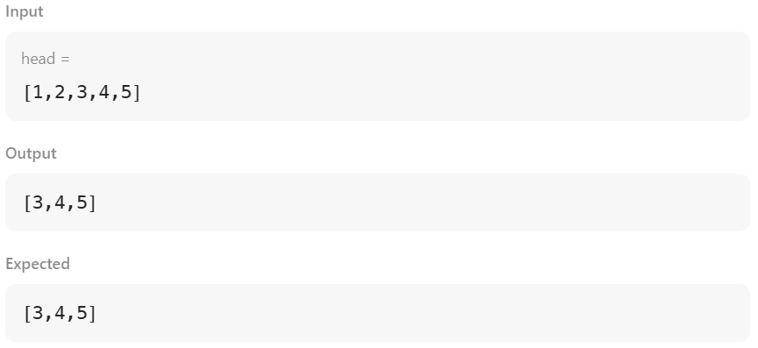

Case 2:
